PROJECT REPORT

On

**“Electronic Shopping ”**

Six Months Industrial Training

At TCIL-IT, Chandigarh

<College logo>

**SUBMITED TO:- SUBMITTED BY:**

<lecture Name> <student name>

Class Roll No: <Branch>

**DECLARATION**

I hereby declare that the Industrial Training Report entitled ("Title of the project") is an authentic record of my own work as requirements of 6-months Industrial Training during the period from _______ to_______ for the award of degree of B.Tech.(Information Technology, **college name** under the guidance of (Name of Project Guide).

**(Signature of student)**

**(Name of Student)**

**(University Roll No.)**

**Date: ____________________**

Certified that the above statement made by the student is correct to the best of our knowledge and belief.

**Head of Department**

**(Signature and Seal)**

***ELECTRONIC SHOPPINGIntroduction***

Analysis is the focus of system developing and is the stage when system designers have to work at two levels of definition regarding the study of situational issues and possible solutions in terms of “what to do” and “how to do”.

**System Study**

***DEFINITION OF THE SYSTEM***

A system is an orderly grouping of independent components linked together according to a plan to achieve a specific objective. Its main characteristics are organization, interaction, independent, integration and central objective a system does not necessarily mean to a computer system. It may be a manual system or any other names.

***NEEDS OF THE SYSTEM***

Social and economic factor: a wave of social and economic changes often follows in the wake of the new technology. New opportunities may arise to improve on a production process or to do something that was not previously possible. Changes in the ways individuals are organized into groups may then be necessary, and the new groups may complete for economic resources with established units.

Technological factor: people have never before in a time when the scope of scientific inquiry was so broad, so when the speed of applying the new technology accounts for many changes in the organization.

High level decisions and operating processes: in response to technological, socio-economical factors, top level managers may decide to recognize operations and introduce new products. To deal with these needs, people commonly seek new modified information to support the decision. When that happens, then they obtain turn to a computer system for help the information users and data processing specialist then work together to complete a series of steps in a system study to produce output results to satisfy information needs.

**System analysis**

System Analysis is a process by which we attribute process or goals to a human activity, determine how well those purpose are being achieved and specify the requirements of the various tools and techniques that are to be used within the system if the system performances are to be achieved.

**SYSTEM PLANNING**

Planning for information systems has a time horizon and a focus dimension. The time horizon dimension specifies the time range of the plan, where as the focus dimension relates whether the primary concern is strategic, managerial, or operational. The system i.e. The Project that we were assigned was required to complete within 20 weeks. What we had planned is as follows:

Requirements analysis, Preliminary Investigation & Information Gathering should be covered within the 1st and 2nd week. Since I was not aware of MYECLIPSE IDE it require 1 week for me to adjust with that tool. 12 Weeks for the design of the system under development. 1 week for Testing & Implementation. And rest 2 reserve weeks.

**PRELIMINARY INVESTIGATION**

The initial investigation has the objective of determining the validity of the user’s request for a candidate system and whether a feasibility study should be conducted.

The objectives of the problem posed by the user must be understood within the framework of the organization’s MIS plan. Ihad investigated from the concerned authority about the project

**INFORMATION GATHERING**

Akey part of feasibility analysis is gathering information about the present system. The analyst must know what information to gather, where to find it, how to collect it, and what to make of it. The proper use of tools for gathering information is the key to successful analysis. The tools are the traditional interview, questionnaires, and on-site observation.

**STRUCTURED ANALYSIS**

The traditional tools of data gathering have limitations. An English narrative description is often vague and difficult for the user to grasp. System flowcharts focus more on physical than on logical implementation of the candidate system. Because of these drawbacks, structured tools were introduced for analysis. Structured analysis is a set of techniques and graphical tools (DFD) that allow the analyst to develop a new kind of system specifications that are easily understandable to the user.

**CONTEXT LEVEL DATA FLOW DIAGRAM**

SELLER

BUYER

**SCREEN LAYOUT**

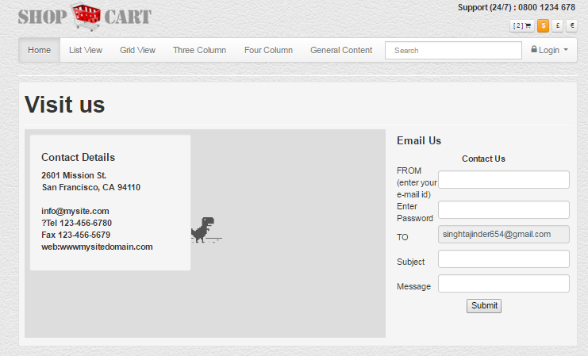

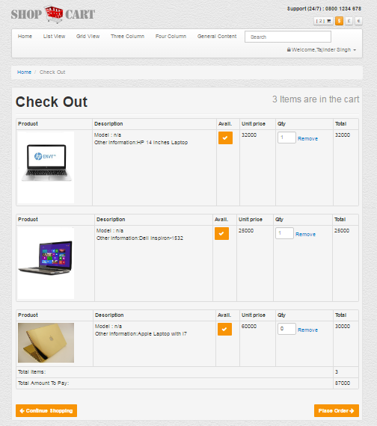

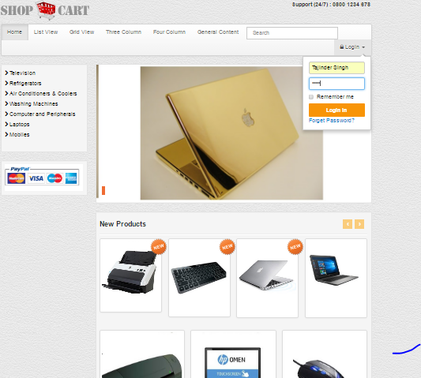

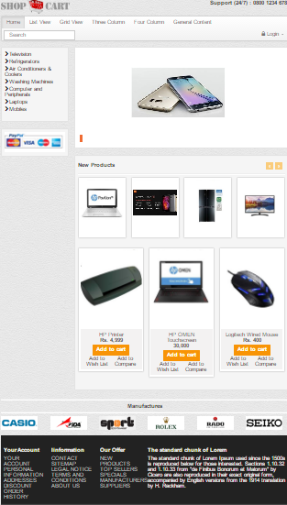

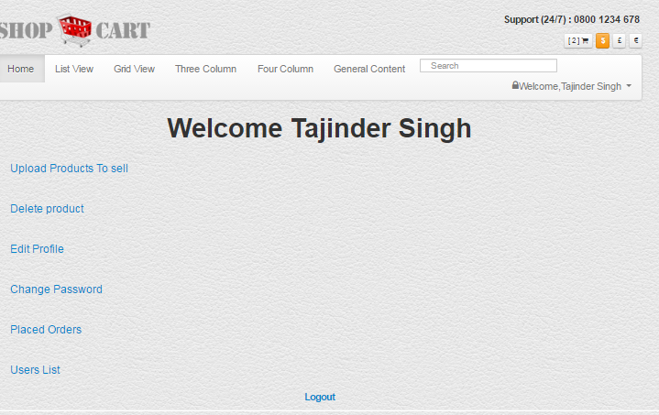



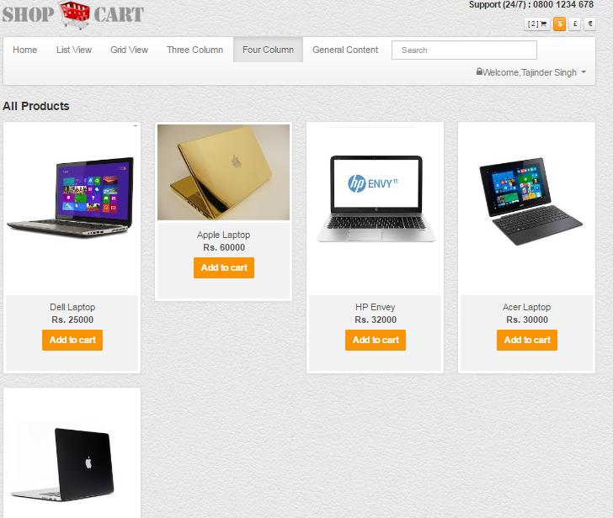

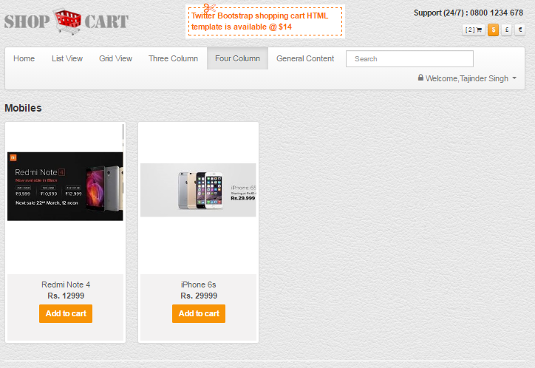

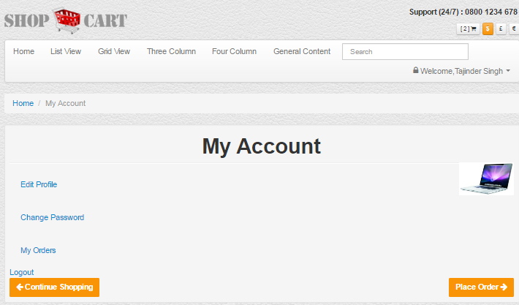

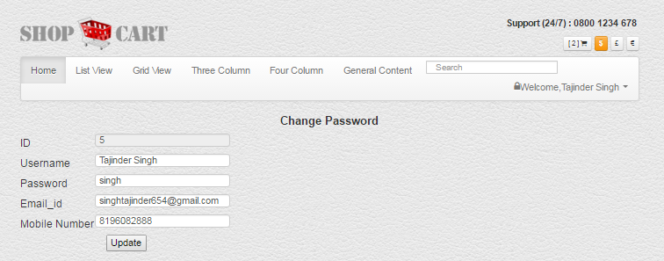

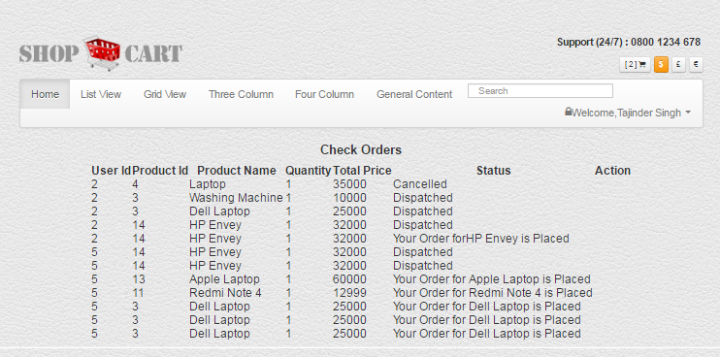

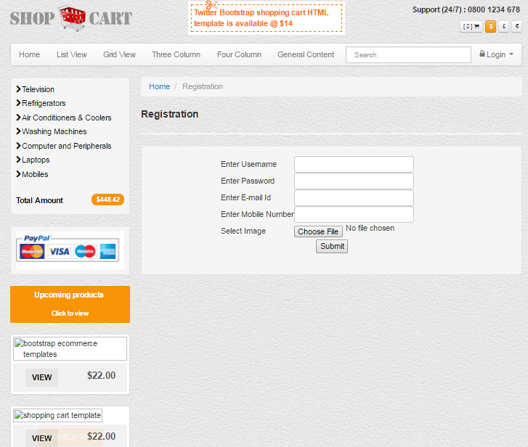

**INTERPRETATION OF**

**THE RESULT**

**The system has been implemented and tested successfully. It meets the information requirements specified to the great extent. although the system has been designed keeping the present and future requirements in mind and made very flexible.**

**There are limitations of the system. proper consideration has been given for a wide range of new enhancements.The system is developed user friendly.In future , if it is required to generate reports other than provided by the system it can be simply achieved by a separate module to the main menu without affecting the design of the system.**

**ADVANTAGES**

**(1)it simplifies the operation.**

**(2)it avoids a lot of manual work.**

**(3)every transaction is obtained and processed immediately.**

**(4)avoids errors by avoiding the manual work.**

**(5)user friendly screen to enter the data and enquire the database tables.**

**(6)online help messages available to the operating system.**

**(7)user can easily access the system without much experience.**

**(8)provide hardware and software securities.**

**(9)portable and flexible for further extensions.**

**Conclusion**

The central concept of the application is to allow the customer to shop virtually using the Internet and allow customers to buy the items and articles of their desire from the store.

The information pertaining to the products are stores on an RDBMS at the server side (store).The Server process the customers and the items are shipped to the address submitted by them.

The application was designed into two modules first Os for the customers who wish to buy the articles. Second is for the storekeepers who maintains and updates the information pertaining to the articles and those of the customers.

The end user of this product is a departmental store where the application is hosted on the web and the administrator maintains the database. The application which is deployed at the customer database, the details of the items are brought forward from the database for the customer view based on the selection through the menu and the database of all the products are updated at the end of each transaction.